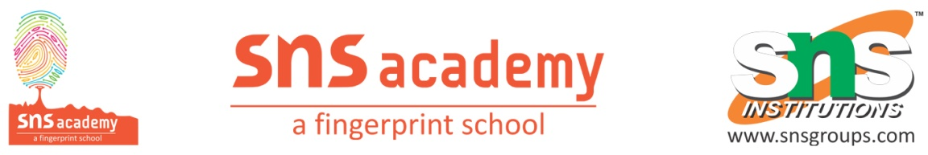

Annual Plan 2024-25

SUBJECT: ENGLISH GRADE : 6
S.No | Topic/ Theme | Term
1  April & June | Unit -1  1.Growing Up  2. Parts of Speech/LSRW  3. Dairy Entry | I
2  July & August | Unit -2  1.Nature’s Beauty  2.Tenses/LSRW | I
3  August &  September | Unit – 3  1.Furs and Feathers  2.Tenses/Degrees of Comparison /LSRW | I
4.  October &  November | Unit – 4  1.Playing Fair  2. Active and Passive Voice /LSRW | II
5.  November, December & January | Unit – 5  1. A Brush with Art  2.Preposition/Conjunction  /LSRW | II
6.  January &  February  March | Unit – 6  1.The Unexplained  2. Kinds of sentences/Direct and Indirect Speech  Revision | II

